### Team Contract

1. **What do you want to get out of Project 1?**    
   Become experienced product designers who willingly take unconventional approaches to problem solving.
2. **What is your team name?**Team K.A.R.
3. **How are you going to communicate when not in person**   
   We have shared our phone, email, and FB, so for immediate issues, FB group chats will be used. For more formal/document-related issues, it will be via email. Urgent issues can be done via phone. We plan to give at least 2 hours of response time for regular issues.
4. **When and where will you meet?**   
   We plan to meet right after Thursday’s lecture until our studio (Thursday 4-5PM) in MD 2nd floor. If needed, we will also meet right after our studio to finalize a couple necessary details before working on our assignments.
5. **What should team members do prior to the team meeting?** They should have read the assignment and have a clear understanding of the deliverables that are required from the meeting.
6. **How are you going to structure your work?**   
   Because we are all very separated geographically, we hope to be flexible in our meetings via Google Hangout calls and working on Google docs together. In the very beginning of the session, we will clearly outline the goals of the meetings and assign tasks so that each of us is responsible for some deliverable by the end of the meeting/day.
7. **How will the assignments get submitted?**Ideally we want this to be done by class on Tuesdays. We will work in pairs with either one person writing and the other checking or both writing and checking each others’ work - depending on how long the final write up is. The other pair is welcome to review and question aspects of the write-up, but should do so before Wednesday.
8. **How will you deal with surprises?** The individual should keep the group updated so that potential problems can be dealt with as early as possible. They should have at least tried to find solutions to their problem before handing it off to someone. They should also make an effort to make it up those people in the future if the problem was their own and not due to an unrealistic analysis of the amount of work that would be required to complete their task.
9. **How will you manage turn taking?**   
   Our team is very enthusiastic to speak our minds and hope people will add onto or challenge the statements made to spark unconventional approaches to tackle a problem. We will let others finish talking before speaking, be willing to clear misunderstandings or confusion as many times as we need to, and completely cover a topic before moving on.
10. **How will you handle conflict?**   
    Unless it’s an unforeseen, extreme circumstance, we hope to respect everyone’s time and effort for this project. But most importantly, it will always be “project first” and not make this personal for anyone. Let’s keep this professional and focused. We plan to have bi-weekly check-ins (3 min at most) to bring up any concerns or issues.
11. **Anything else** you think will be important for your team. We want this to fun and interesting for all group members and want to make sure that our communication is good so that we can address any issues quickly and effectively.

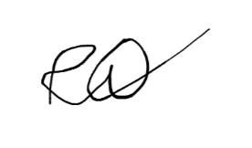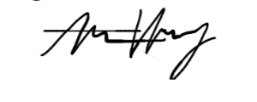

Alice Huang Kevin Yoon Robert Waddilove